**Nov 2015 HL P1**

**Section A**

1. Human interaction with the computer system includes a range of usability problems.
2. Define the term usability. [1]

Usability means making the computer systems easy to use, matching them more closely to user needs and requirements;

1. Identify **two** methods that could be used to improve the accessibility of a computer

system. [2]

Voice recognition;

Text to speech;

Use of touch screen;

Braille keyboard;

*Etc*.

1. By making direct reference to the technologies used, explain how a virtual private network

(VPN) allows a travelling salesperson to connect securely to their company’s network. [4]

*Award* ***[1]*** *for identifying a technology and* ***[1]*** *for explaining it, for* ***two*** *technologies, up to* ***[4 max]***.

Tunnelling protocols;

Allows the data to be encapsulated/hidden whilst travelling across the internet;

Encryption protocols (IPSEC);

If hacked it will not be understandable;

The use of gateways;

Allows the salesperson to connect with the company’s server;

1. Construct a truth table for the following Boolean expression.  
     
    (A and B) nor C [3]

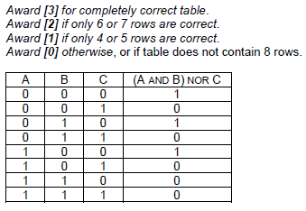

1. A school uses a local area network (LAN) which connects several computers and a printer to

a server and allows access to the internet.

1. Define the term server. [1]

A computer system that serves as a central repository of data and programs and is shared by clients;

1. Identify the different clients in this network. [1]

Computer / Printer;

1. (i) Identify **one** external threat to the security of the school’s computer system. [1]

*Award* ***[1 max]***.

Viruses;

Spyware;

Hackers who attempt to crack the system;

***Note:*** *Do not accept theft/vandalism/natural disasters*

(ii) State one way to protect the computer system from the threat identified in

part (c)(i). [1]

*Award* ***[1 max]***.

Virus checker can be used to prevent viruses;

Spyware program run to check for spyware;

Firewall can be used to protect from hackers;

***Note:*** *Do not accept secure storage/guards/alarms to prevent theft in the building*

1. A sub-program all_even() accepts a positive integer N and outputs true if all digits of N

are even, otherwise it outputs false. For example, all_even(246) outputs true and

all_even(256) outputs false.

The following algorithm is constructed for the sub-program all_even(N).

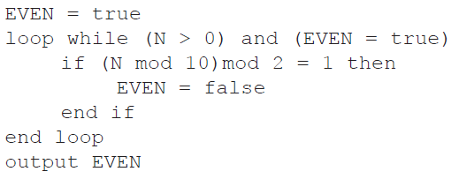

1. Explain why this algorithm does not obtain the correct result. [2]

*Award up to* ***[2 max]***.

The value of N is never changed;

So the logical expression in the while loop always evaluates to true;

And loop repeats an infinite number of times;

1. Outline what should be changed in the algorithm to obtain the correct result. [3]

Statement N = N div 10;

Should be written within the while loop;

After the if statement;

1. (a) Draw an annotated diagram showing how an array can be used to store a stack. [2]

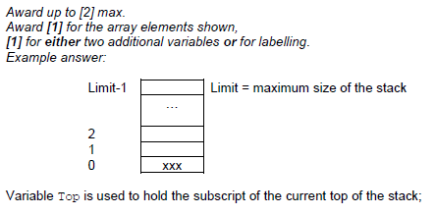

(b) Explain how elements in the stack may be reversed using a queue. [4]

*Award up to* ***[4 max]***.

Create an empty queue;

While stack is not empty;

Pop an element from the stack;

Enqueue the popped element;

While queue is not empty;

Dequeue;

Push dequeued element back on the stack;

***Note:*** *Award a maximum of* ***[2]*** *for answers that just describe how a stack and a queue work.*

**Section B**

1. A hardware shop supplies a wide variety of bathroom equipment. There are 15 shop

assistants who serve customers, 3 office staff who handle the administration, and a manager.

A specialized company is asked to design and implement a new computer system for

the shop.

1. (i) Identify two different types of users of the system. [2]

*Award up to* ***[2 max]***.

Customers;

Employees – shop assistants;

Employees – office staff;

Manager / Owner; **[2]**

*Award* ***[1]*** *for “Employees”, if type of employee is not specified*

(ii) Explain the role of users in the process of developing the new computer system. [3]

*Award up to* ***[3 max]***.

Role of users is important because inadequate user involvement leads to project failure;

All users must participate and explain how they use the system;

All users must participate and explain what they think is wrong with the system;

Users (managers, owners) are involved in approval of projects and budgets;

All users are involved in testing of the system;

All users are involved in training;

*Etc*.

1. Describe why it is useful to produce more than one prototype of the new system. [2]

More than one prototype allows the manager to choose the one that is the most suitable;

Which gives more flexibility and improves final system;

1. Outline two problems that may occur when transferring data from the old system to the

new system. [4]

*Award* ***[2]*** *for a correct answer,* ***[1]*** *for an answer with some credit, for two problems.*

*Example answers:*

The data records in databases could have different structures (fields);

The data files could be incompatible, from different hardware systems;

The key fields of different data types can exist;

The customer records could have same keys (IDS) so they cannot be uniquely identified;

The manager of the shop has decided to invest in a computer system which allows customers  
 to make online orders from any place at any time.

1. (i) Explain how two or more customers are able to access the computer system at

the same time. [2]

The central computer/server is a multi-user environment / running a multi-user OS;

Which shares its time amongst customers;

(ii) Explain how each customer’s data is secure when two customers access the  
 system at the same time. [2]

OS protects user/customer data when in RAM;

To prevent overwriting or accidental changes;

1. 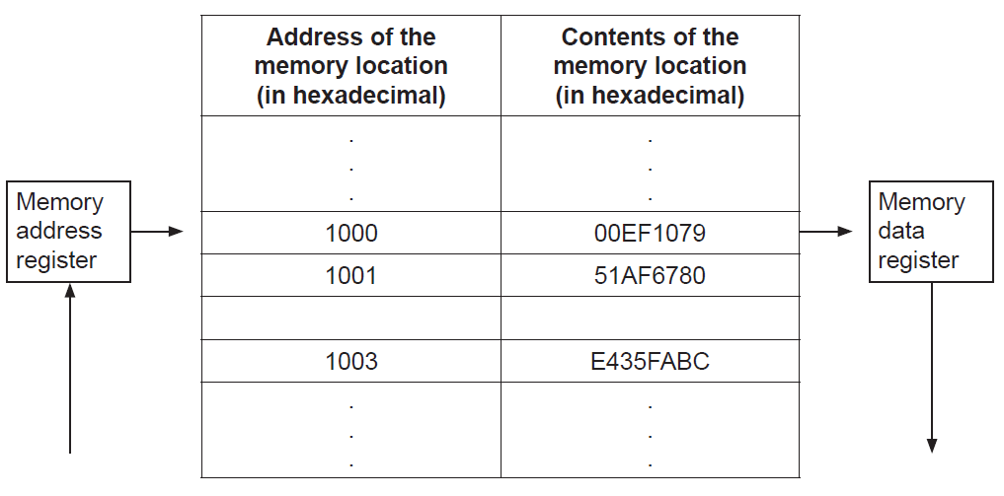The following diagram shows the structure of the random access memory (RAM).
2. Calculate the number of bits in each memory location. [1]

32

1. Calculate the number of bytes in each address. [1]

2

1. Outline the function of the:
2. memory address register [2]

*Award up to* ***[2 max]***.

MAR is a register in the CPU;

Loaded with the address of the next instruction/data;

To be taken from the RAM;

1. memory data register. [2]

*Award up to* ***[2 max]***.

MDR is a register in the CPU;

Holding the data which is most recently;

Taken from RAM;

1. (i) Identify two functions of the operating system. [2]

*Award up to* ***[2 max]***.

Resource allocation;

Memory management;

Interrupt handling; **[2]**

*Etc*.

(ii) State where the operating system is held when the computer is turned off. [1]

*Award up to* ***[1 max]***.

Hard disk;

ROM;

Solid state disk (SSD);

The machine instruction cycle refers to the retrieval of an instruction from the RAM, and  
 subsequently decoding, executing and storing the result.

1. (i) Construct a diagram to illustrate the structure of a central processing unit (CPU),

clearly showing the flow of data within the CPU. [4]

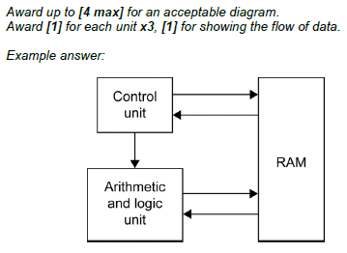

(ii) Identify the part of the CPU which performs decoding. [1]

Control unit;

(iii) Identify the part of the CPU which executes the instruction. [1]

Arithmetic and logic unit;

1. A control system is used to control sliding doors which automatically open to allow people in

and out of a shop.

1. (i) Identify one type of sensor in this system. [1]

*Award up to* ***[1 max]***.

Proximity;

Movement;

Pressure

(ii) Identify one piece of hardware, other than sensors, that is part of the control  
 system. [1]

*Award up to* ***[1 max]***.

Transducers;

AD converters;

Actuators;

Micro-processor;

(iii) With reference to the role of sensors, outline the sequence of steps within the  
 computer control system that will take place when a person approaches the door. [3]

*Award up to* ***[3 max]***.

When a person approaches, sensors activate;

Signal sent to processor;

Which sends signal to actuator/transducer (which opens doors);

After fixed time/no further sensory input, doors close;

1. (i) Define the term interrupt. [2]

*Award up to* ***[2 max]***.

Interrupt is a signal sent to the processor;

Sent by hardware or software;

Indicating an event that needs the processor’s immediate attention;

(ii) Describe a situation in this system where an interrupt would occur. [2]

If a second person approaches the door while it is closing;

This will interrupt the processing cycle and the door will re-open;

1. Discuss the contribution of computer control systems in industry where they replace

human workers. [6]

*Award* ***[1]*** *for an advantage/disadvantage and* ***[1]*** *for an expansion, for 3 examples, up to* ***[6 max]****.*

*Example discussion points:*

Labour cost;

Quality of work;

Retraining;

Redundancy;

Performance (of repetitive tasks);

Productivity;

Safety;

*Example answer:*

Initially a computer system is more expensive;

Once the computer control system is installed/set up it is more economical;

(Over longer period of time), than human labour;

Computers can work accurately;

7 days/24 hours;

Performing monotonous/unpleasant tasks without complaining;

In dangerous conditions (fumes, poison, lifting heavy weight, *etc*); **[**

1. 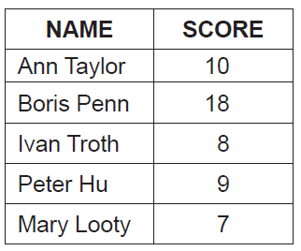The table below holds student names and scores, from a class test.
2. Draw a diagram to show how the data given in the table could be stored in a binary tree

in the order of scores. Data should be inserted into the binary tree in the order given in

the table (ie data about Ann Taylor is to be inserted first). [3]

*Award marks as follows up to* ***[3 max]****.*

*Award* ***[1]*** *for correct nodes (2 data fields and two pointers)*.

*Award* ***[1]*** *for correct root*.

*Award* ***[1]*** *for correct left subtree*.

*Award* ***[1]*** *for correct right subtree*.

Award ***[1]*** for trees that display either only names or only numbers, provided that they are structurally correct.

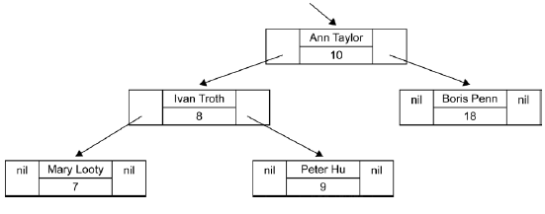

1. The same data could be inserted into a singly linked list in descending order of scores.

Draw a diagram of this singly linked list. [3]

*Award marks as follows up to* ***[3 max]****.*

*Award* ***[1]*** *for correct nodes (2 data fields and one pointer field)*.

*Award* ***[1]*** *for correct order (links shown)*.

*Award* ***[1]*** *for the external pointer to list and showing the end of the list (nil)*.



1. Compare the data structures in part (a) and part (b) in terms of:  
     
   (i) searching [2]

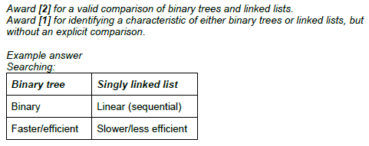

(ii) storage requirements. [2]

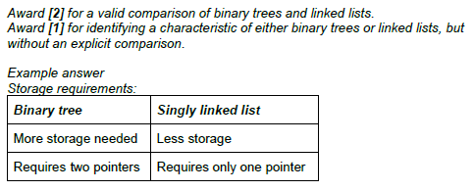

1. 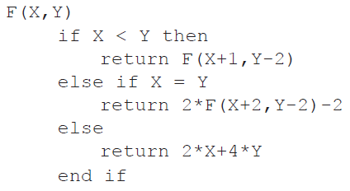Consider the following **recursive** algorithm, in which X and Y are parameters in the  
   method F. The return statement gives the value that the method generates.  
     
     
     
     
     
     
     
     
     
   Determine the value of F(5,11). [5]

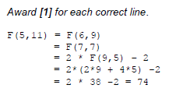

1. A population study divides a metropolitan area into seven regions: A–G.

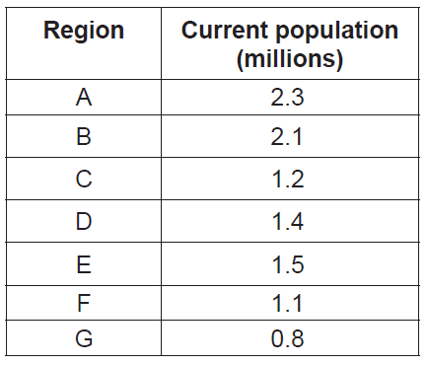The following table shows the current population (in millions) of the regions.

Two one-dimensional arrays, Region and Curr_Pop, are used to hold this data.

For example, Region[0] ='A'. The population in region A is 2.3 million and 2.3 is found in

Curr_Pop[0].

1. Construct the algorithm that will output the total population in the metropolitan area. [3]

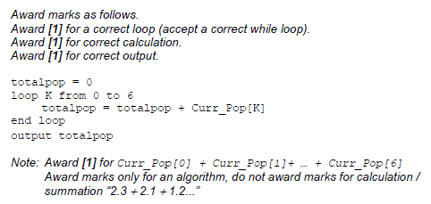

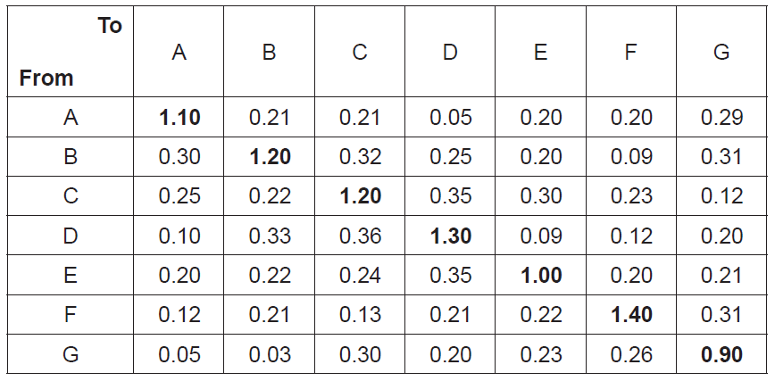 The numbers in the following table represent expected percentages of yearly migration from  
 one region to another, obtained by analysing historical migration data. For example, it is  
 expected that 0.32 % of the current population of region B will move to region C.  
 The diagonal entries represent a region’s internal growth rate. For example, the population  
 of region C is expected to increase by 1.2 % as a result of the births and deaths of people  
 currently living in region C.

1. (i) State the percentage of the population of region G that are expected to move to

region A. [1]

0.05 (%);

(ii) Determine the number of people from region B who are expected to move to  
 region E. [1]

0.0042 (million) / 4200;

*Award* ***[1]*** *for 0.2 * 2.1 /100*.

(iii) Describe how the change in population of region F in one year could be

determined. [3]

*Award up to* ***[3 max]***.

Current population in the region F should be increased by the internal growth rate;

Increased by the population who moved into the region;

And decreased by the population who moved from this to other regions;

*Accept formulas that correctly address these points.*

1. Construct the algorithm that will predict the population in each region after 10 years.

You should assume that the yearly migration percentages, given in the table on page 8,

remain the same over the 10 years. [7]

